Abstract template (max. 3 pages)

NOVEL BIO-POLYMERS FOR ………………..
Radim Hrdinaª, John Smith^{b}, ………………………….
ª Faculty of Chemical Technology, University of Pardubice, Czech Republic
^{b} University of ……………
Corresponding author: Radim Hrdina; radim.hrdina@upce.cz

Abstract/Extended abstract
Novel bio-polymers such as hyaluronic acid, chitin and chitosan have been intensively investigated for medicinal and cosmetic purposes [1,2].
.
.
Prepared fibres (Fig. 1) were …………………..

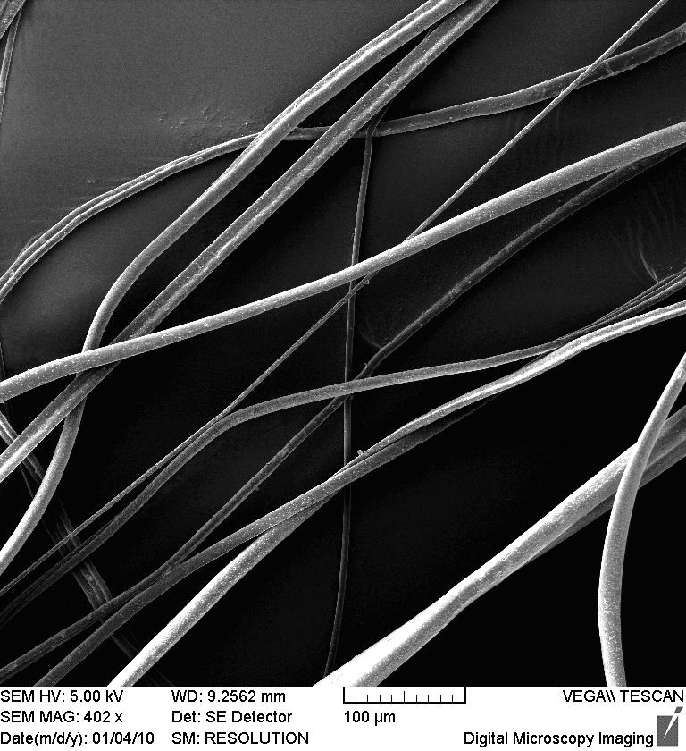

Figure 1. EMS of prepared fibre
.
.

Hydrazine hydrate was used as the reducing agent for silver oxide (Eq. 1).
Equation 1.
.
.
Incorporation of silver into fibre (Scheme 1) was ………………

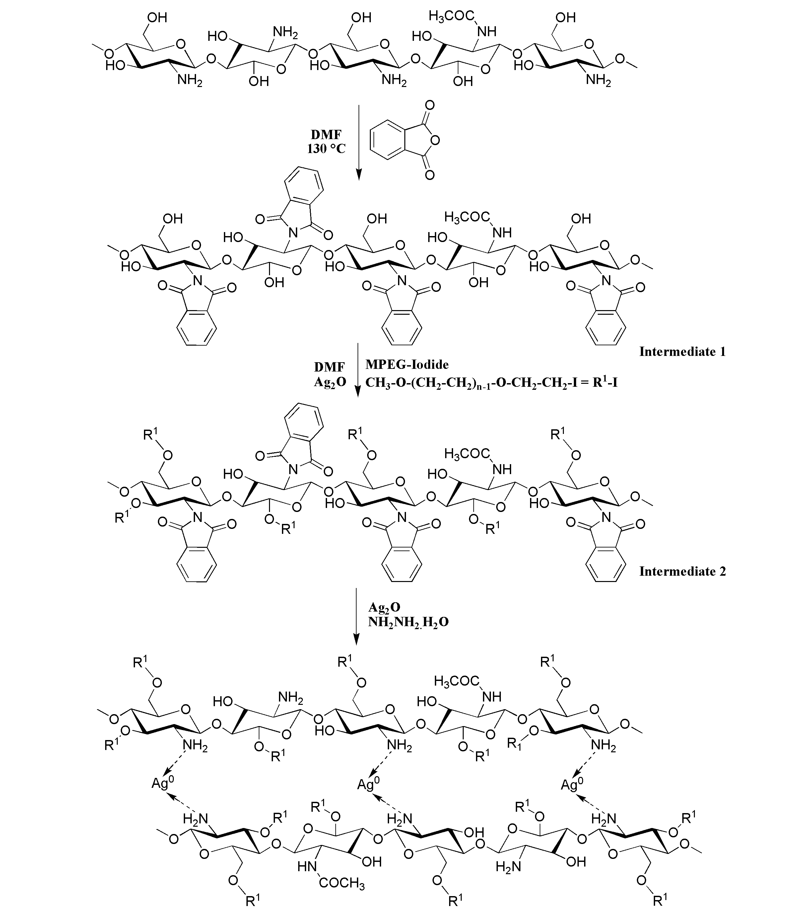

Scheme 1. Reaction of ……………
.
.

Reaction conditions (Tab. 1) were ……………..

Table 1. Reaction conditions

Entry | Temperature (ºC) | Yield (%) | Remark
1 | 80 | 65
2

.
.

References
- Burgert, Ladislav; Hrdina, Radim; Masek, David; Velebny, Vladimir: PCT Int. Appl. (2012), WO 2012089179 A1 20120705.
- Abdel-Mohsen, A. M.; Hrdina, Radim; Burgert, Ladislav; Krylova, Gabriela; Abdel-Rahman, Rasha M.; Krejcova, Anna; Steinhart, Milos; Benes, Ludvik: Carbohydrate Polymers (2012), 89(2), 411-422.

